Canva Training
canva.com

Part 1: How to design your materials—choose a template
On the left-hand menu, click “KGI”.
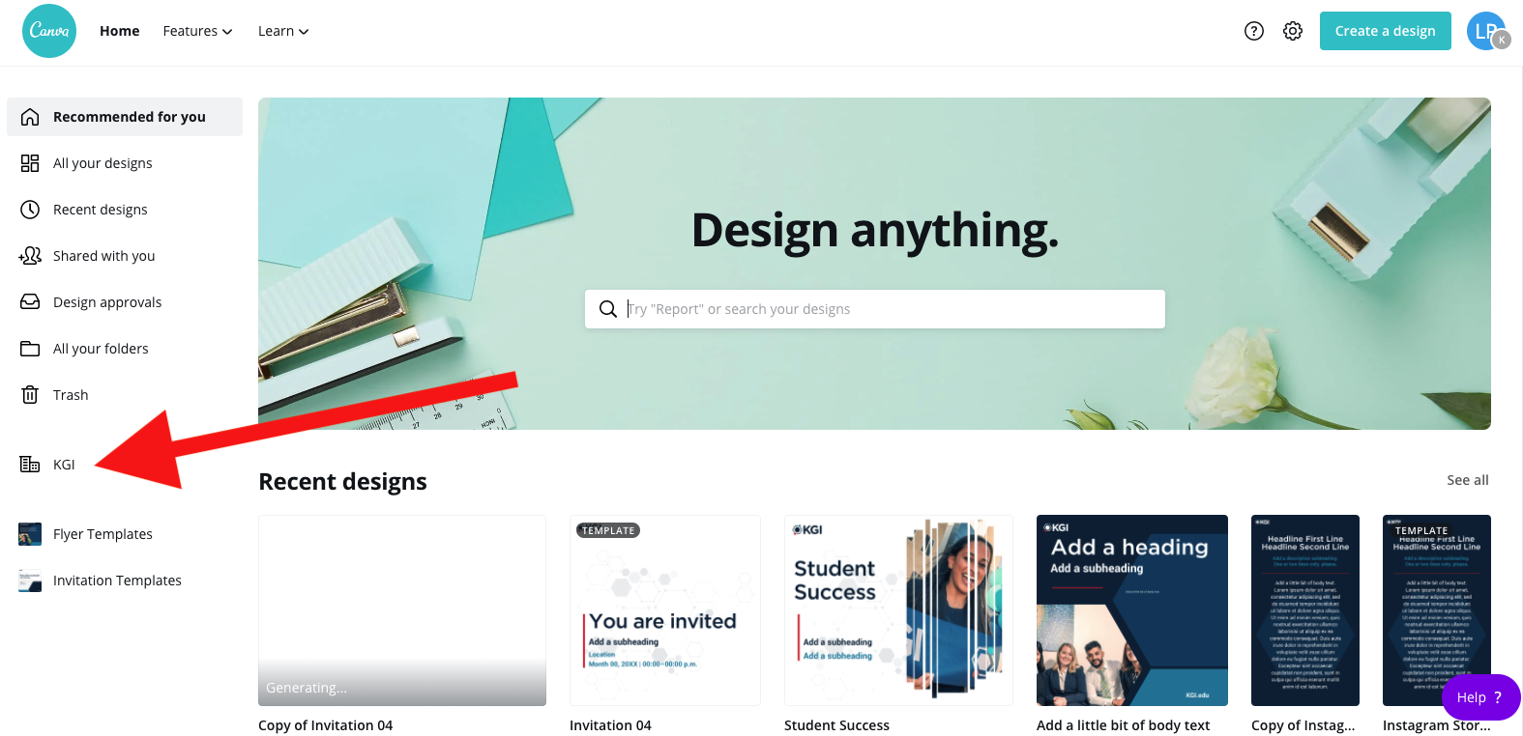

In the middle sub-menu, click on “Folders”.
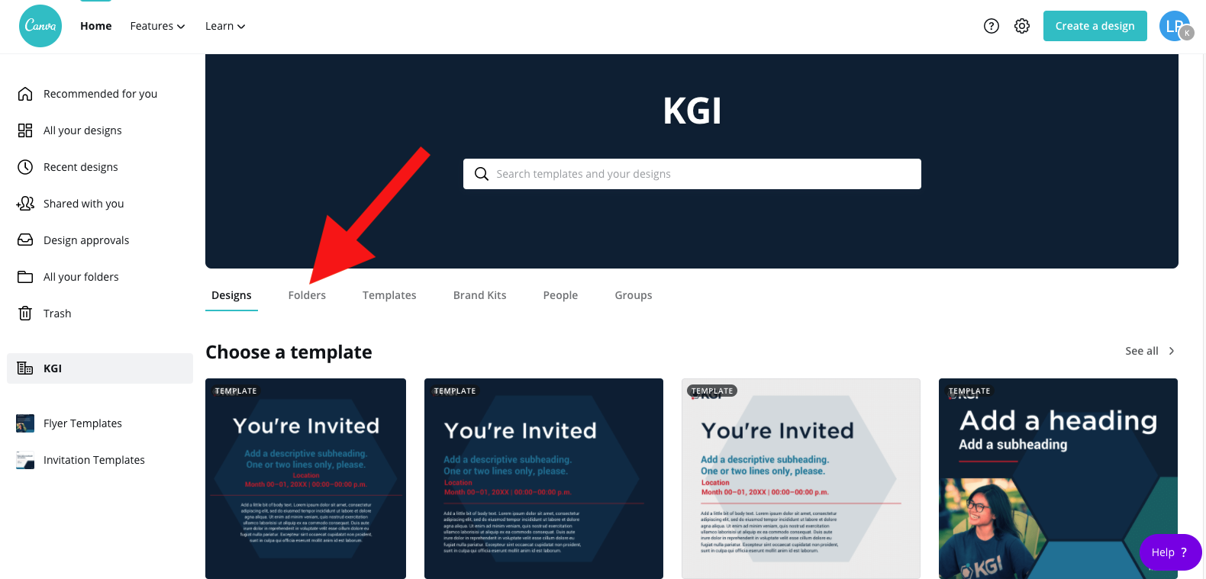

Decide what kind of material you need to create. Is it a flyer? Invitation? Select the folder that pertains to what you want to create.
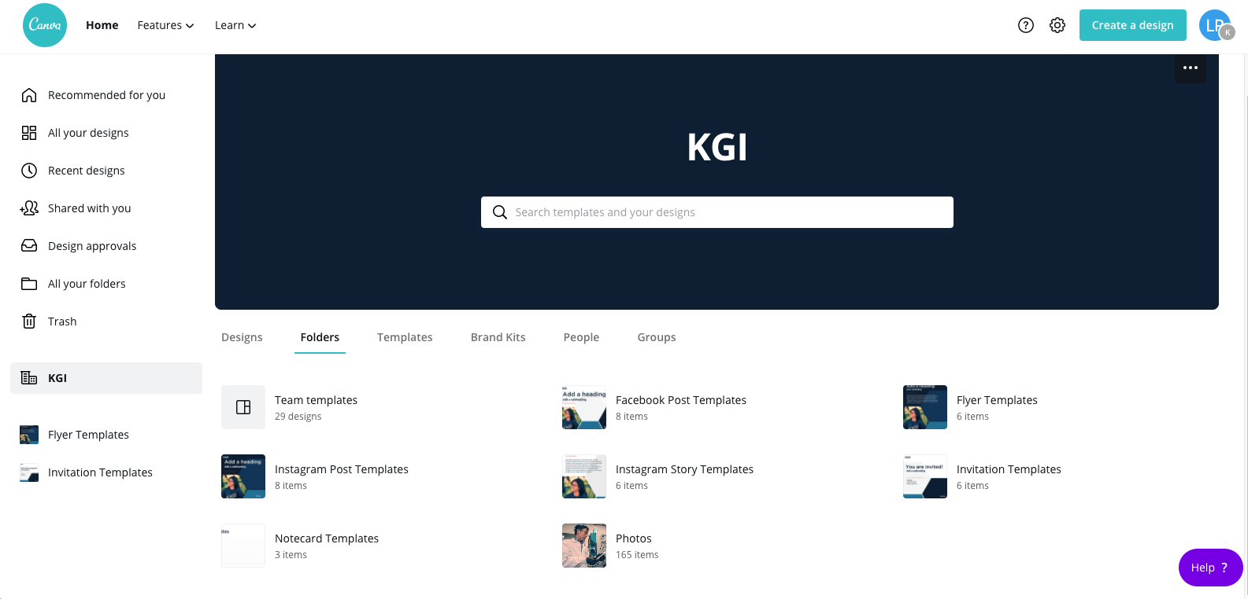
Once you’re in the folder, there are multiple designs. Chose the layout that you’d like to use.
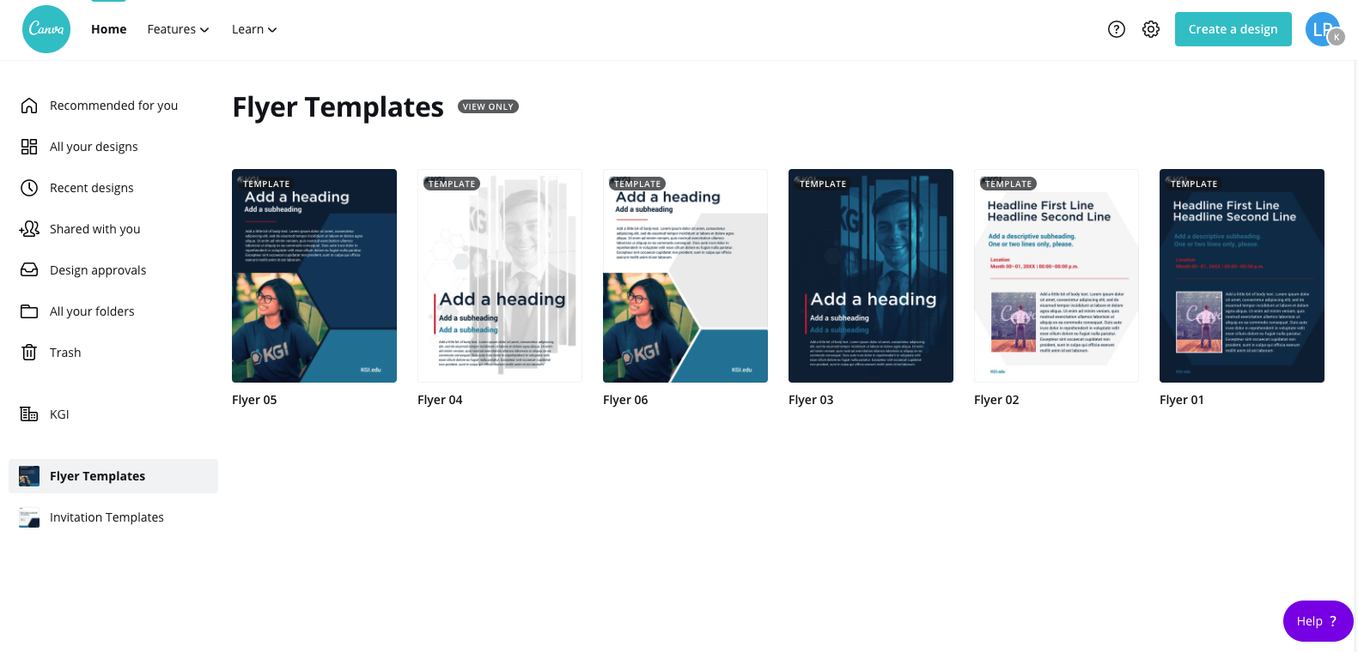
Once you click the layout, click the button “use this template” to begin creating your material.
Part 2: Editing the template
Once you’ve selected the template, you will be taken to the editing page. The template that you selected will pre-populate.
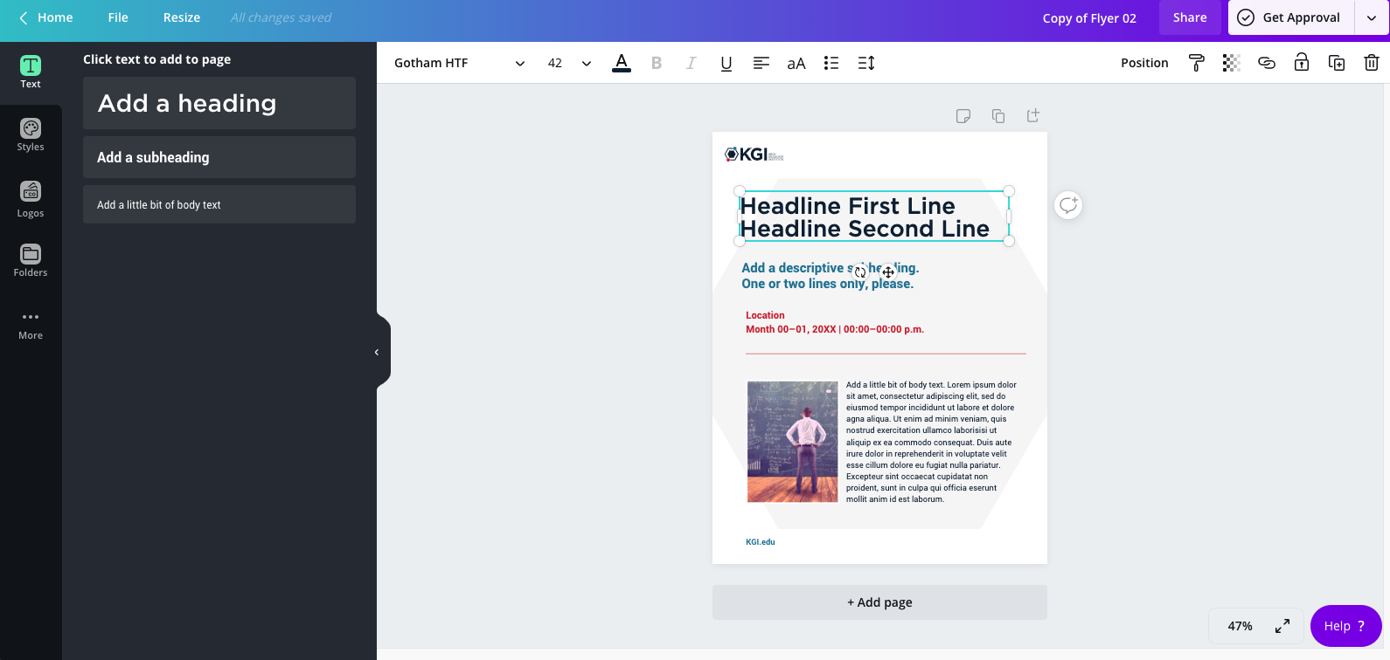
Editing text
- Once you click on a text box, a toolbar at the top populates with simple text options.
- Be sure to edit all the text that you need with your specific information.
- Delete text boxes that you don’t need.
- You can also move each text box around depending on the length of your content.
- The font size can be altered.
- Font colors can also be altered, but we recommend you stick with the colors pre-populated.
Replacing the photo (if your template has a photo) or adding a photo
Click the “folders” button on the left.
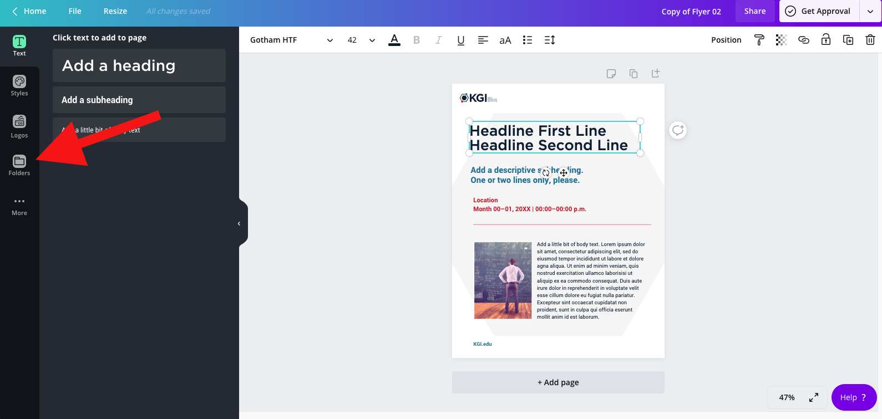
Click the “shared with you” tab below the search bar.
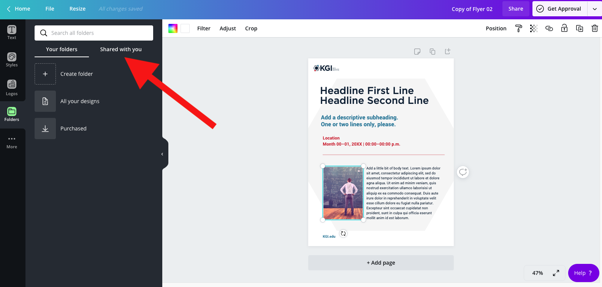
Scroll down until you see the “photos” folder
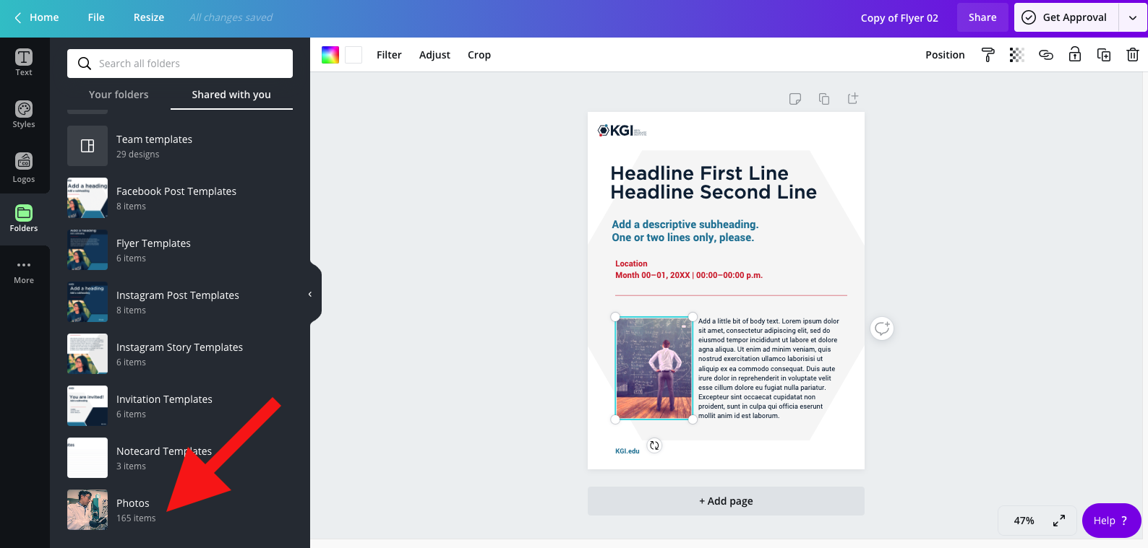
View the photos until you see one that will fit your material. Then, click on that photo and drag it into the box on your design. Or, simply click on it, and it will insert into your design (you may have to move it around and/or delete the original).
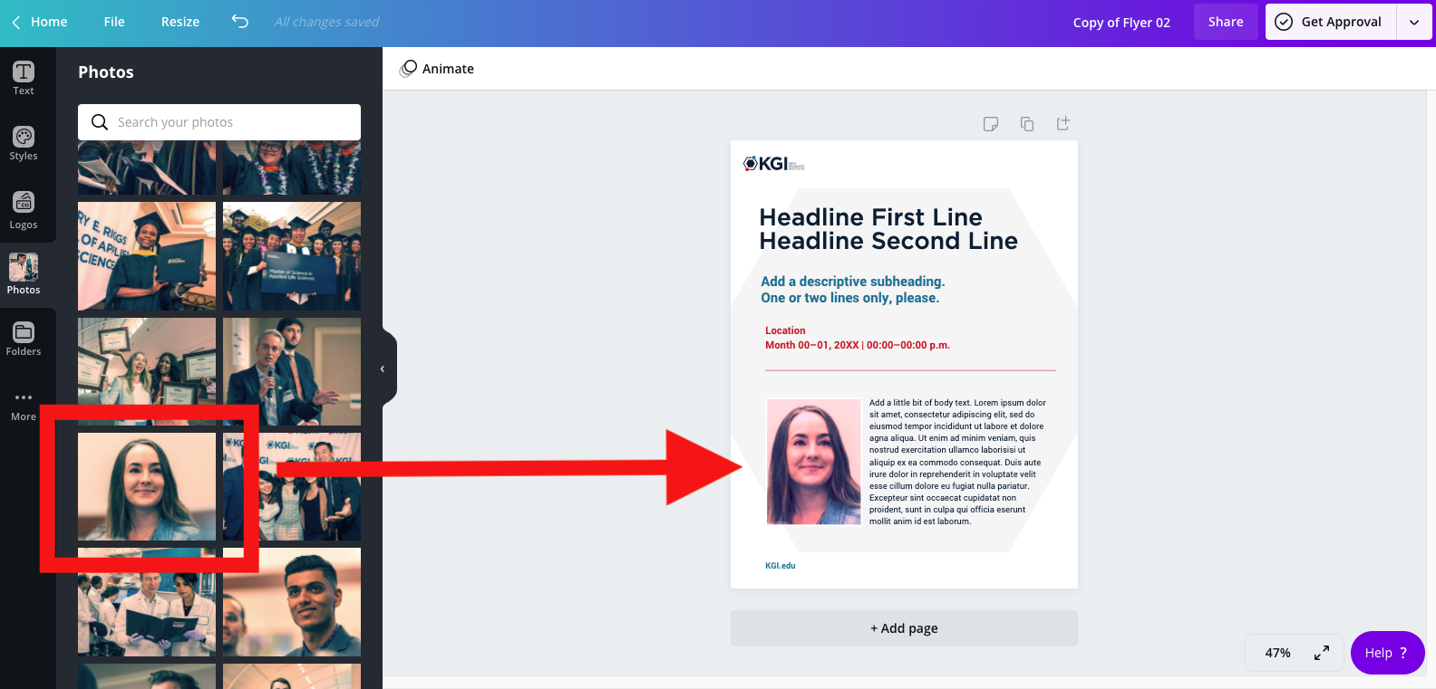
Click on the photo, and a toolbar populates up top with some options to crop or adjust.
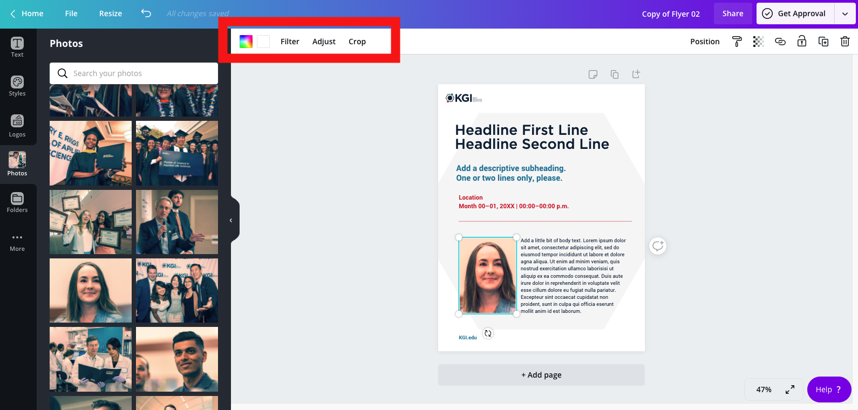
Uploading a photo
If you are creating something that requires a specific photo (i.e. you want to use the headshot of the person who is speaking), then you can upload that person’s photo.
Click on the uploads button on the top left, and then select from where you want to upload (i.e. your device).
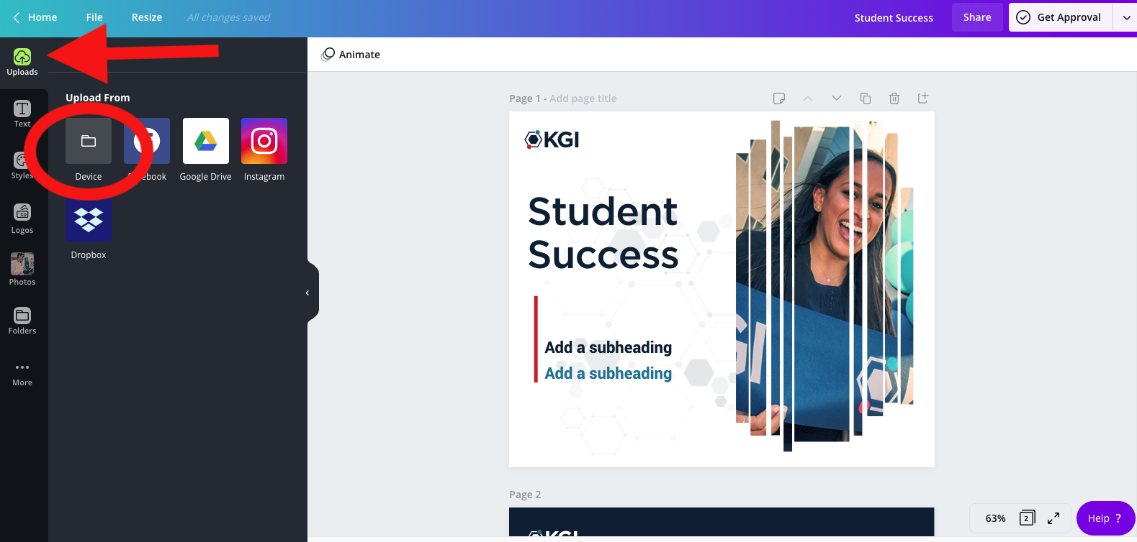
Adding additional text
If you need to add more text boxes, select the “text” tab on the left. You then have the option of adding a heading, subhead, or body text. Simply click on the text and it will populate onto the template. Then, move it around to the desired location, and edit the language.
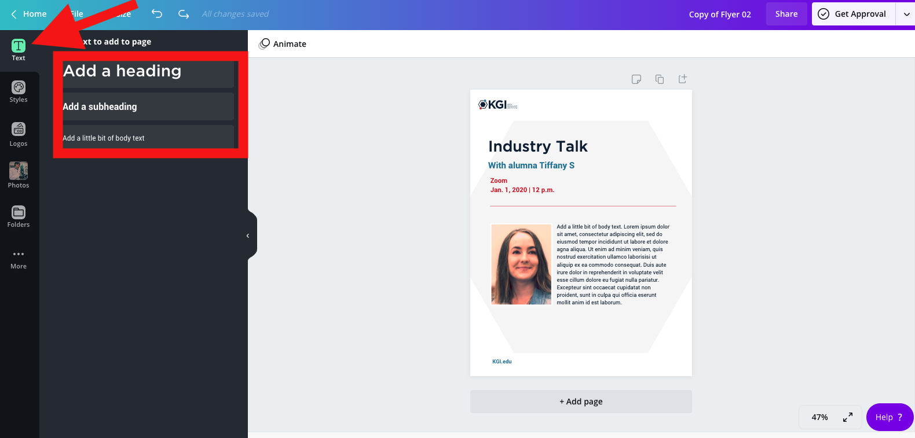
Name your material
Your material name will default to a copy of the template that you’re using. In order to label your material, click in the top right and type in the name of your piece (i.e. Industry Talk flyer). This will help to organize your materials.
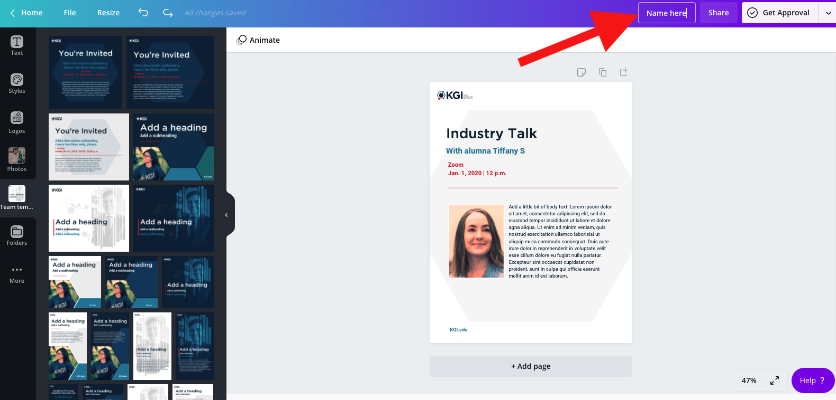
Part 3: Getting approval
Once your flyer is complete, you need to click the top right button “get approval”. Be sure to select “KGI Brand” as the approver.
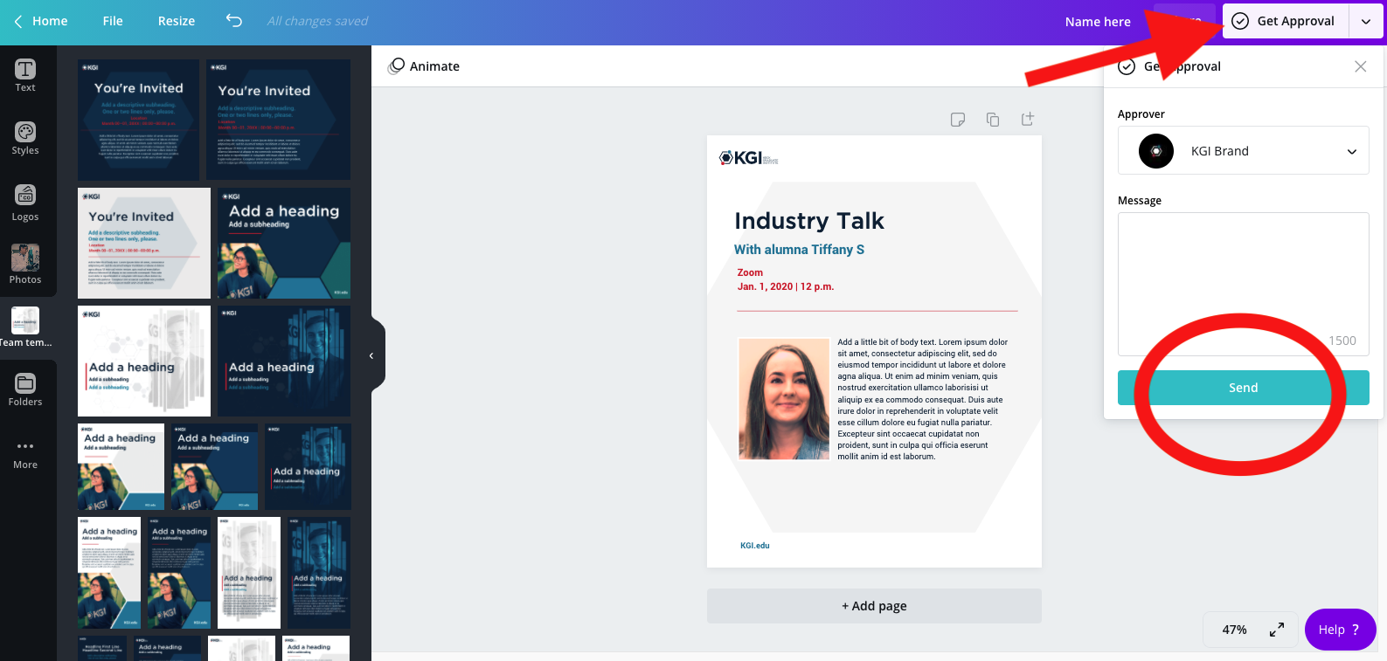
Once you hit the “send” button, a member of the KGI Marketing team will review your design and either provide feedback on changes to make, or approve it. You will receive an email notification once your design has been approved, and you will then be able to download your material.

