Creating a
Table of Contents in Microsoft Word
  - Scroll down for instructions

How to create a table of contents in Microsoft Word 2
What is the table of contents? 2
How do I create a table of contents? 2
Structure 2
Use the Styles Panel 2
Inserting your own table of contents 2

How to create a table of contents in Microsoft Word
A table of contents in Word is based on the formatting of the document it is being applied to. The key lies in the formatting and use of the pre-built styles contained within this template.

What is the table of contents?
By default, the table of contents is a function of Word that pulls all of the Heading 1, Heading 2, and Heading 3 paragraph styles and compiles them into an outline-style list, arranged by page number, to help the reader navigate long documents. This list populates semi-automatically (*see note) as the document changes.

How do I create a table of contents?
Page 2 of this document contains an example table of contents built using this series of paragraphs as its basis. If you’re creating your own, however, there are some things to keep in mind.

Structure
First and foremost, structure your document correctly. Use the pre-built styles contained within the ‘Styles Pane’ to semantically format your document. For instance, use Heading 1 for main sections, Heading 2 for Subsections, and Heading 3 as article headers.
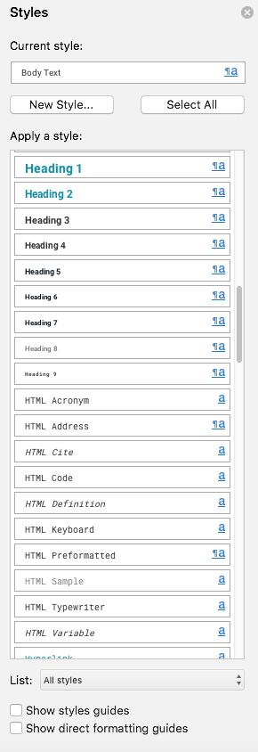

Use the Styles Panel
The Style Pane can be accessed by selecting the Home tab, then selecting the Styles Pane from the tool ribbon across the top of the document window.
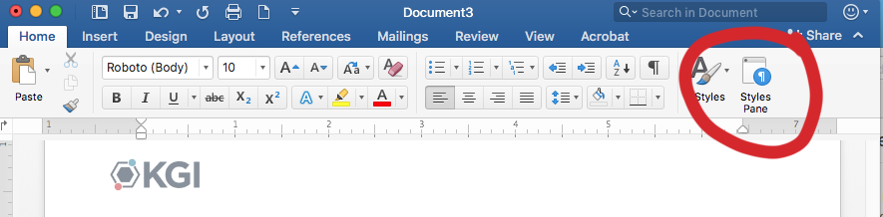
The Styles Pane will open to reveal the styles contained within the template. Use these styles to format your document. This is done by selecting the appropriate style before typing. To style existing text, simply place your cursor within the paragraph you wish to style, then selecting the style from the Style Pane.

Inserting your own table of contents
Once you format your document, and the sections/subsections/articles that you want to appear in the table of contents have the proper heading styles applied to them, you are ready to insert the table of contents.
- Place the cursor where you want the table of contents to appear, usually on its own page.
- Choose Insert from the menu bar and select Index and Tables…
- Inside the dialog box, select Table of Contents.
- Choose “From Template” in the Format box.
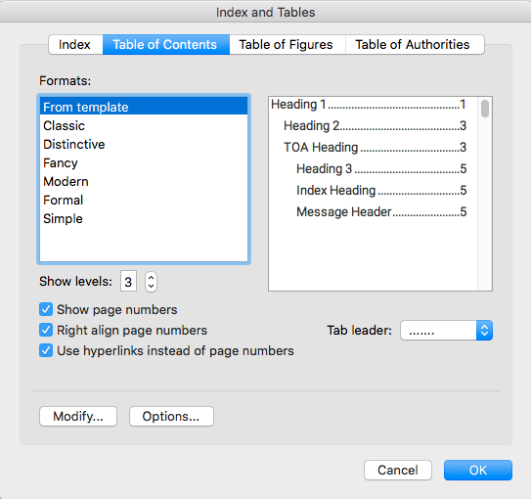
From this dialog box many modifications can be made. If none are desired, choose ok. The table of contents will populate automatically.
Note: If the document is updated, and pages are added/subtracted, the table of contents will need to be updated as well. To update the table of contents, simply right click and select Update Field.

