## PANCE Pass Rates

The below tables represent the most recent five‐year first-time Physician Assistant National Certifying Exam (PANCE) pass rates provided by the National Commission on Certification of Physician Assistants (NCCPA). This summary report compares KGI MSPA program results to the national first-time taker pass rate and will be updated with each graduating cohort. Note the first graduating class was the Class of 2024, who completed the program in December 2024.

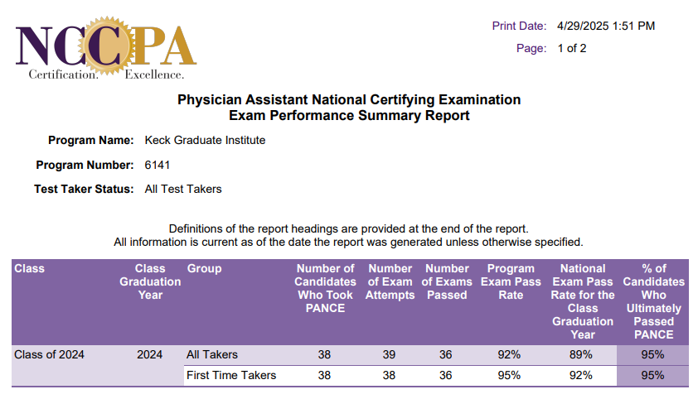

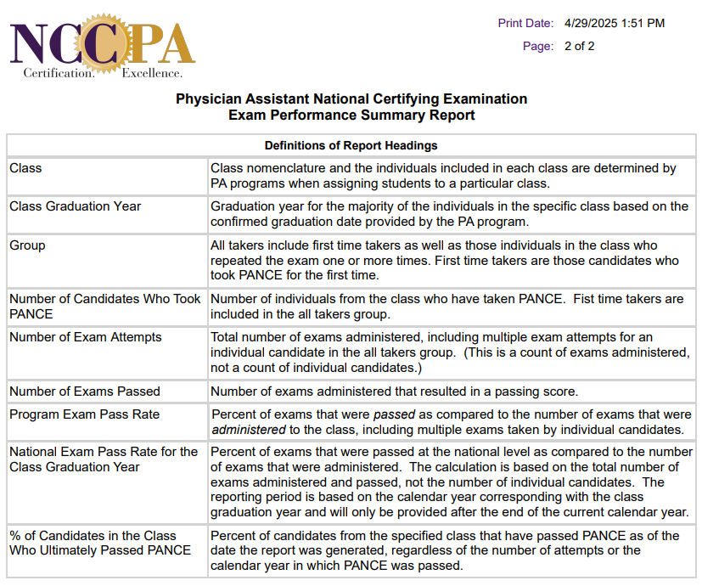



## ARC-PA Student Attrition

This reflects the most current attrition information for the KGI MSPA program. Upon graduation of the first cohort, the program will provide attrition information for the KGI MSPA program’s graduated cohorts and the most recent data for the cohorts currently in matriculation.

|  |  |  |  |
| --- | --- | --- | --- |
|  | **Graduated Classes** | | |
|  | **Class of 2024** | **Class of 2025** | **Class of 2026** |
| **Maximum Entering Class Size** (as approved by ARC-PA) | **40** | **40** | **40** |
| Entering Class Size | **40** | **41** | **40** |
| Graduates | **38** | # | # |
| **\* Attrition Rate** | **5%** | # | # |
| **\*\* Graduation Rate** | **95%** | # | # |

*Attrition rate calculation: Number of students who attritted from cohort (decelerated + withdrawals + dismissals) divided by the (entering class size + number joining class cohort).

**Graduation rate: Number of cohort graduates divided by the (entering class size + number joining cohort).

**Comments:**

One student from the Class of 2024 joined the Class of 2025.